**Building a Data Lake.**

**Module introduction.**

Welcome to the module on building a data lake.

We'll start by revisiting what data lakes are, and discuss your data storage and options for extracting, transforming, and loading your data into Google Cloud.

Then we'll do a deep dive into why Google Cloud Storage is a popular choice to serve as a data lake.

Securing your data lake running on Cloud Storage is of paramount importance.

We'll discuss the key security features that you need to know as a data engineer to control access to your objects.

Cloud Storage isn't your only choice when it comes to storing data in a data lake on Google Cloud.

So we'll look at the storing of different data types.

Finally, we'll look at Cloud SQL, the default choice for OLTP or Online Transaction Processing Workloads on Google Cloud.

You'll also do a hands-on lab where you'll practice creating a data lake for your relational data with Cloud SQL.

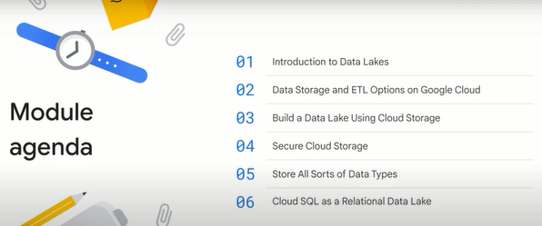

**Introduction to data lakes.**

Let's start with a discussion about what data lakes are and where they fit in as a critical component of your overall data engineering ecosystem. What is a data lake after all? It's a fairly broad term, but it generally describes a place where you can securely store various types of data of all scales for processing and analytics.

Data lakes are typically used to drive data analytics, data science, and ML workloads, or batch and streaming data pipelines. Data lakes will accept all types of data. Finally, data lakes are portable on premise or in the Cloud.

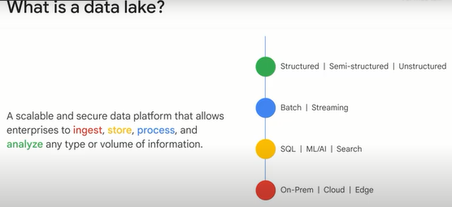

Here's where data lakes fit into the overall data engineering ecosystem for your team. (*Aquí es donde encajan los datalakes en el ecosistema general de ingeniería de datos para su equipo*.)

You have to start with some originating system or systems that are the source of all your data. Those are your data sources, then, as a data engineer, you need to build reliable ways of retrieving and storing that data. Those are your data syncs. The first line of defense in an enterprise data environment is your data lake. (*Debe comenzar con algún sistema o sistemas de origen que sean la fuente de todos sus datos. Esas son sus data sources, luego, como ingeniero de datos, necesita crear formas confiables de recuperar y almacenar esos datos. Esas son sus repositorios de datos. La primera línea de defensa en un entorno de datos empresariales*

*es su datalake.*)

Again, it's the central "give me whatever data at whatever volume, variety of formats and velocity you got, I can take it." We'll cover the key considerations and options for building a data lake in this module. Once your data is off the source systems and inside your environment, generally, considerable cleanup and processing is required to transform that data into a useful format for the business. It will then end up in your data warehouse. That's our focus for the next module. What actually performs the cleanup and processing of data? Those are your data pipelines, they are responsible for doing the transformations and processing on your data at scale, and bring your entire system to life with freshly, newly processed data for analysis. An additional abstraction layer above your pipelines is what I will call your entire workflow. You will often need to coordinate efforts between many different components at a regular or event-driven cadence. While your data pipeline may process data from your lake to your warehouse, your orchestration workflow may be the one responsible for kicking off that data pipeline in the first place when it noticed that there was a new raw data available from a source. Before we move into what Cloud products can fit what rolls, I want to leave you with an analogy that helps disambiguate these components. Picture yourself in the world of civil engineering for a moment, you're tasked with building an amazing skyscraper in a downtown city. Before you break ground, you need to ensure you have all the raw materials that you're going to need to achieve your end objective. Sure, some materials could be sourced later in the project, but let's keep this example simple. The act of bringing the steel, the concrete, the water, the wood, the sand, the glass, from wherever source elsewhere in the city onto your construction site is analogous to data coming from source systems and into your lake. Great. Now you have all these raw materials, but you can't use them as is to build your building, you need to cut the wood and metal, measure and format the glass before it is suited for the purpose of building the building. The end result, the cut glass, shaped metal, that is the formated data that is stored in your data warehouse. It is ready to be used to directly add value to your business, which in our analogy is building the building. How did you transform these raw materials into useful pieces? On a construction site, that's the job of the worker. As you'll see later when we talk about data pipelines, the individual unit behind the scenes is literally called a worker, which is just a virtual machine, and it takes some small piece of data and transforms it for you. What about the building itself? That's whatever end goal or goals you have for this engineering project. In the data engineering world, the shiny new building could be a brand new analytical insight that wasn't possible before, or a machine learning model, or whatever else you want to achieve now that you have the cleaned data available. The last piece of the analogy is the orchestration layer. On a construction site, you have a manager or a supervisor that directs when work has to be done and any dependencies. They could say, once the new metal gets here, send it to this area of the site for cutting and shaping and then alert this other team that it's available for building. In the data engineering world, that's your orchestration layer or overall workflow. So you might say, every time a new piece of CSV data drops into this Cloud storage bucket, I want you to automatically pass it to our data pipeline for processing. And once it's done processing, I want you, the pipeline, to stream it into the data warehouse. And once it's in the data warehouse, I will notify the machine learning model that new cleaned training data is available for training and directed to start training a new model version. Can you see the graph of actions building? What if one step fails? What if you want to run that every day? You're beginning to see the need for an orchestrator, which in our solutioning will be Apache Airflow running on Cloud composer later. Let's bring back one example solution architecture diagram that you saw earlier in the course. The data lake here is Cloud storage buckets right in the center of the diagram. It's your consolidated location for raw data that is durable and highly available. In this example, our data lake is a Cloud storage, but that doesn't mean Cloud Storage is your only option for data lakes. Cloud Storage is one of a few good options to serve as a data lake. In other examples, we will look at BigQuery may be your data lake and your data warehouse, and you don't use Cloud storage buckets at all. This is why it's so important to understand what you want to do first and then find which solutions best meet your needs. Regardless of which Cloud tools and technologies you use, your data lake generally serves as that single consolidated place for all your raw data. Think of it as a durable staging area, the data may end up in many other places like a transformation pipeline that cleans it up, moves it to the warehouse, and then it's read by a machine learning model, but it all starts with getting that data into your lake first. Let's do a quick overview on some of the core Google Cloud big data products that you need to know as a data engineer, and we'll practice later in your labs.

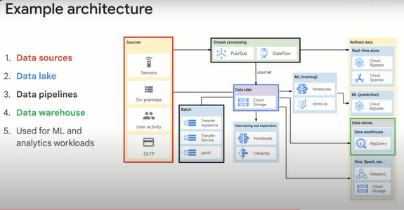

Here is a list of big data and ML products organized by where you would likely find them in a typical data processing workload from storing the data on the left to ingesting it into your Cloud native tools for analysis, training machine learning models, and serving up insights.

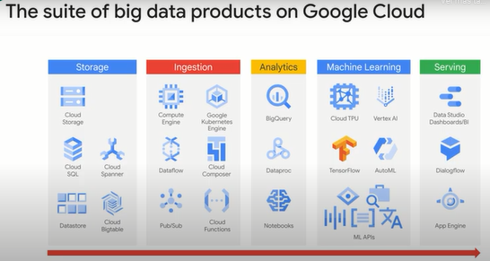

In this data lake module, we will focus on two of the foundational storage products which will make up your data lake: Cloud storage and Cloud SQL for your relational data.

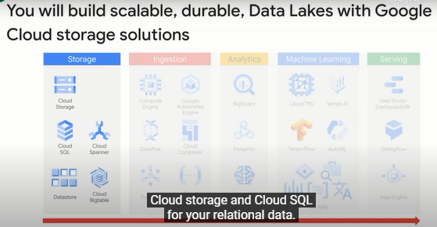

Later in the course, you will practice with Cloud Bigtable as well when you do high throughput streaming pipelines. You may be surprised to not see big query in the storage column. Generally, BigQuery is used as a data warehouse. What's the core difference between a data lake and a data warehouse then? A data lake is essentially the place where you capture every aspect of your business operations. Because you want to capture every aspect, you tend to store the data in its natural raw format, the format in which it is produced by your application. So you may have a log file and the log file stored as is in a data lake, you can basically store anything that you want. And because you want to store it all, you tend to store these things as object blobs or files. The advantage of the data lake's flexibility as a central collection point is also the problem. With a data lake, the data format is very much driven by the application that writes the data, and it is in whatever format that is. The advantage of a data lake is that whenever the application gets upgraded, it can start writing the new data immediately, because it's just a capture of whatever raw data exists. So how do you take this flexible and large amount of raw data and do something useful with it?

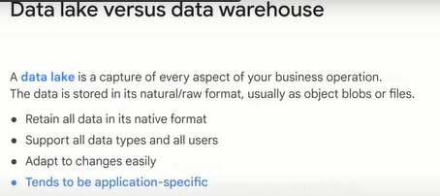

Enter the data warehouse. On the other hand, a data warehouse is much more thoughtful (reflexive). You might load the data into a data warehouse only after you have a schema defined and the use case identified. You might take the raw data that exists in a data lake and transform it, organize it, process it, clean it up, and then store it in a data warehouse. Why are you getting the data warehouse? Maybe because the data in the Data Warehouse is used to generate charts, reports, dashboards, and so on. The idea is that because the schema is consistent and shared across all of the applications, someone can go ahead and analyze the data and derive insights from it much faster. So a data warehouse tends to be structured and semi-structured data that is organized and placed in a format that makes it conducive for querying and analysis.

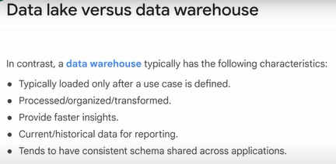

**Data storage and ETL options on Google Cloud.**

Next, let's discuss your data storage, and extract, transform and load options on Google Cloud.

Your options on Google Cloud for building a data lake are your storage solutions you saw earlier.

You've got Cloud Storage as a great catchall (comodín), Cloud SQL and Cloud Spanner for relational data, and Firestore and Cloud Bigtable for NoSQL data.

Choosing which option or options to use depends heavily on your use case and what you're trying to build.

In this lesson, we will focus on Cloud Storage and Cloud SQL, but you will see the NoSQL options like Cloud Bigtable later on in the course when we talk about very high throughput streaming.

So how do you decide on which path to take for your lake?

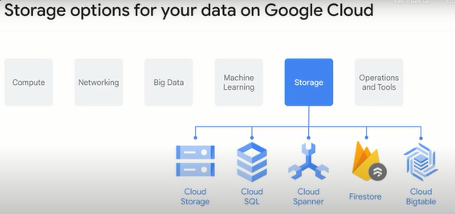

The final destination for where your data lands on the cloud and the paths that you take to get your data to the cloud depends on where your data is now.

How big your data is.

This is the volume component of the three Vs of big data.

And ultimately, where does it have to go.

In architecture diagrams, the ending point for the data is called a data sync.

A common data sync after a data lake is your data warehouse.

Don't forget a critical thing to consider is how much processing and transformation your data needs before it is useful to your business.

Now you may ask, "Do I complete the processing before I load it into my data lake, or afterward, before it gets shipped off somewhere else?"

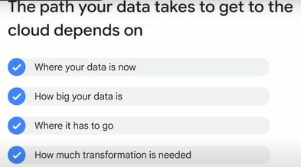

Let's talk about these patterns.

The method that you use to load the data into the cloud depends on how much transformation is needed from the raw data that you have to the final format you want it in.

In this lesson, we will look at some of the considerations for the final format that you want it in.

The simplest case might be that you have data in a format that is readily ingested by the cloud products that you want to store it in.

Let's say for example you have your data in Avro format and you want to store the data in BigQuery because your case fits what BigQuery is good at.

Then what you do is simply EL, or extract and load.

BigQuery will directly load Avro files.

EL refers to when data can be imported as-is into a system.

Examples include importing data from a database where the source and the target have the same schema.

One of the features that makes BigQuery unique is that as you saw before with the federated query example, you may end up not even loading the data into BigQuery and still can query off of it.

Avro, ORC and Parquet files are all now supported for federated querying.

The T in ELT is transform.

That's when the data loaded into the cloud product isn't in the final format you want it in.

You may want to clean it up, or maybe you want to transform the data in some way.

For example, if data needs to be corrected.

In other words, you would extract from your on-premise system, load into the cloud product and then do the transformation.

That's an extract, load and transform, or ELT.

You tend to do this when the amount of transformation that's needed is not very high and the transformation will not greatly reduce the amount of data that you have.

ELT allows raw data to be loaded directly into the target and transformed there.

For example, in BigQuery, you could use SQL to transform the data and write a new table.

The third option is extract, transform and load, or ETL.

This is the case when you want to extract the data, apply a bunch of processing to it and then load it into the cloud product.

This is usually what you pick when this transformation is essential, or if this transformation greatly reduces the data size.

So by transforming the data before loading it into the cloud, you might be able to greatly reduce the network bandwidth that you need.

If you have your data in some binary proprietary format and you need to convert it before loading, then you need ETL as well.

ETL is a data integration process in which transformation takes place in an intermediate service before it is loaded into the target.

For example, the data might be transformed in a data pipeline like data flow before being loaded into BigQuery.

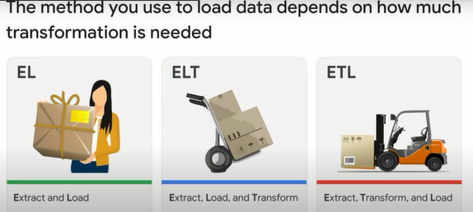

**Build a data lake using Cloud Storage.**

Cloud Storage is the essential storage service for working with data, especially unstructured data in the cloud.

Let's do a deep dive into why Google Cloud Storage is a popular choice to serve as a data lake.

Data in Cloud Storage persists beyond the lifetime of VMs or clusters, i.e. it is persistent.

It is also relatively inexpensive compared to the cost of compute.

So, for example, you might find it more advantageous to cache the results of previous computations in Cloud Storage.

Or if you don't need an application running all the time, you might find it helpful to save the state of your application into Cloud Storage and shut down the machine it is running on when you don't need it.

Cloud Storage is an object store, so it just stores and retrieves binary objects without regard to what data is contained in the objects.

However, to some extent, it also provides file system compatibility and can make objects look like and work as if they were files so you can copy files in and out of it.

Data stored in Cloud Storage will basically stay there forever.

In other words, it is durable, but is available instantly.

It is strongly consistent.

You can share data globally, but it is encrypted and completely controlled and private if you want it to be.

It is a global service, and you can reach the data from anywhere.

In other words, it offers global availability.

But the data can also be kept in a single geographic location if you need that.

Data is served up with moderate latency and high throughput.

As a data engineer, you need to understand how Cloud Storage accomplishes these apparently contradictory qualities, and when and how to employ them in your solutions.

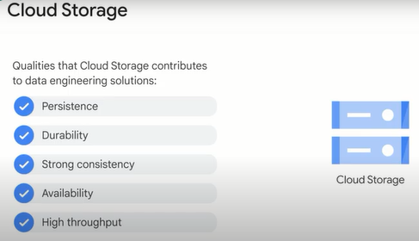

A lot of Cloud Storage's amazing properties have to do with the fact that it is an object store, and other features are built on top of that base.

The two main entities in Cloud Storage are buckets and objects.

Buckets are containers for objects, and objects exist inside of buckets and not apart from them.

So buckets are containers for data.

Buckets are identified in a single global unique namespace.

So that means once a name is given to a bucket, it cannot be used by anyone else unless and until that bucket is deleted and the name is released.

Having a global namespace for buckets simplifies locating any particular bucket.

When a bucket is created, it is associated with a particular region or with multiple regions.

Choosing a region close to where the data will be processed will reduce latency.

And if you are processing the data using cloud services within the region, it will save you on network egress charges.

When an object is stored, Cloud Storage replicates the object.

It monitors the replicas, and if one of them is lost or corrupted, it replaces it with a fresh copy.

This is how Cloud Storage gets many 9s of durability.

For a multi-region bucket, the objects are replicated across regions.

And for a single-region bucket, the objects are replicated across zones.

In any case, when the object is retrieved, it is served up from the closest replica to the requester, and that is how low latency occurs.

Multiple requesters could be retrieving the objects at the same time from different replicas, and that is how high throughput is achieved.

Finally, the objects are stored with metadata.

Metadata is information about the object.

Additional Cloud Storage features use the metadata for purposes such as access control, compression, encryption and life cycle management.

For example, Cloud Storage knows when an object was stored and it can be set to automatically delete after a period of time.

This feature uses the object metadata to determine when to delete the object.

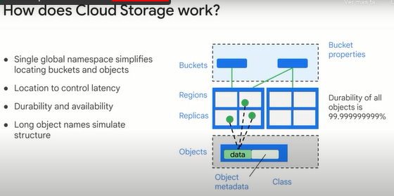

You may have a variety of storage requirements for a multitude of use cases.

Cloud Storage offers different classes to cater for these requirements, and these are based on how often data is accessed.

Standard storage is best for data that is frequently accessed, also referred to as hot data, and/or stored for only brief periods of time.

When used in a region, colocating your resources maximizes the performance for data-intensive computations and can reduce network charges.

When used in a dual region, you still get optimized performance when accessing Google Cloud products that are located in one of the associated regions, but you also get the improved availability that comes from storing data in geographically separate locations.

When used in a multi-region, standard storage is appropriate for storing data that is accessed around the world, such as serving website content, streaming videos, executing interactive workloads or serving data supporting mobile and gaming applications.

Nearline storage is a low-cost, highly durable storage service for storing infrequently accessed data.

Nearline storage is a better choice than standard storage in scenarios where slightly lower availability, a 30-day minimum storage duration and costs for data access are acceptable trade-offs for lowered at-rest storage costs.

Nearline storage is ideal for data you plan to read or modify on average once per month or less.

Nearline storage is appropriate for data backup, long-tail multimedia content and data archiving.

Coldline storage is a very low-cost, highly durable storage service for storing infrequently accessed data.

Coldline storage is a better choice than standard storage or nearline storage in scenarios where slightly lower availability, a 90-day minimum storage duration and higher costs for data access are acceptable trade-offs for lowered at-rest storage costs.

Coldline storage is ideal for data you plan to read or modify at most once a quarter.

Archive storage is the lowest-cost, highly durable storage service for data archiving, online backup and disaster recovery.

Archive storage has higher costs for data access and operations as well as a 365-day minimum storage duration.

Archive storage is the best choice for data that you plan to access less than once a year.

For example, cold data storage such as data stored for legal or regulatory reasons, and disaster recovery.

Cloud Storage is unique in a number of ways.

It has a single API, millisecond data access latency, and 11 9s durability across all storage classes.

Cloud Storage also offers object life cycle management, which uses policies to automatically move data to lower-cost storage classes as it is accessed less frequently throughout its life.

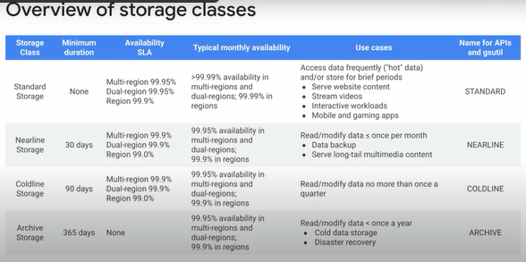

Cloud Storage uses the bucket name and object name to simulate a file system.

This is how it works.

The bucket name is the first term in the URI.

A forward slash is appended to it, and then it is concatenated with the object name.

The object name allows the forward slash character as a valid character in the name.

The very long object name with forward slash characters in it looks like a file system path, even though it is just a single name.

In the example shown, the bucket name is declass.

06:48

The object name is de/modules/02/script.sh.

The forward slashes are just characters in the name.

If this path were in a file system, it would appear as a set of nested directories beginning with declass.

Now for all practical purposes, it works like a file system, but there are some differences.

For example, imagine that you wanted to move all the files in the 02 directory to the 03 directory inside the modules directory.

In a file system, you would have actual directory structures, and you would simply modify the file system metadata so that the entire move is atomic.

But in an object store simulating a file system, you would have to search through all the objects contained in the bucket for names that had 02 in the right position in the name.

Then you would have to edit each object name and rename them using 03.

This would produce apparently the same result, moving the files between directories.

However, instead of working with a dozen files in a directory, the system had to search over possibly thousands of objects in the bucket to locate the ones with the right names and change each of them.

So the performance characteristics are different.

It might take longer to move a dozen objects from directory 02 to directory 03 depending on how many other objects are stored in the bucket.

During the move, there will be list inconsistency, with some files in the old directory and some in the new directory.

A best practice is to avoid the use of sensitive information as part of bucket names because bucket names are in a global namespace.

The data in the buckets can be kept private if you need it to be.

Cloud Storage can be accessed using a file access method.

That allows you, for example, to use a copy command from a local file directly to Cloud Storage.

Use the tool gs to do this.

Cloud Storage can also be accessed over the web.

The site, storage.cloud.google.com, uses TLS HTTPS to transport your data, which protects credentials as well as data in transit.

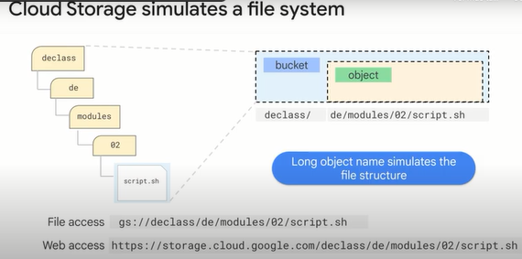

Cloud Storage has many object management features.

For example, you can set a retention policy on all objects in the bucket.

For example, the objects should expire after 30 days.

You can also use versioning so that multiple versions of an object are tracked and available if necessary.

You might even set up life cycle management to automatically move objects that haven't been accessed in 30 days to nearline, and after 90 days to coldline.

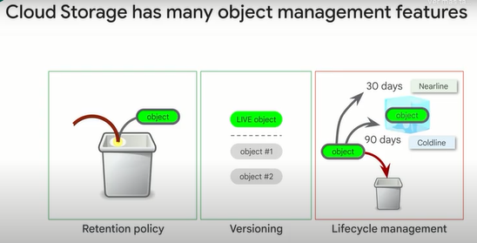

**Secure Cloud Storage.**

Securing your data lake running on Cloud Storage is of paramount importance.

We'll discuss the key security features you need to know as a data engineer to control access to your objects.

Cloud Storage implements two completely separate but overlapping methods of controlling access to objects, IAM policy and access control lists.

IAM is standard across the Google Cloud.

It is set at the bucket level and applies uniform access rules to all objects within a bucket.

Access control lists can be applied at the bucket level or on individual objects, so it provides more fine-grained access control.

The IAM controls are as you would expect.

IAM provides project roles and bucket roles, including bucket reader, bucket writer and bucket owner.

The ability to create or change access control lists is an IAM bucket role.

And the ability to create and delete buckets and to set IAM policy is a project level role.

Custom roles are available.

Project level viewer, editor and owner roles make users members of special internal groups that give them access by being members of bucket roles.

See the online documentation for details.

When you create a bucket, you are offered the option of disabling access lists and only using IAM.

Access lists are currently enabled by default.

This choice used to be immutable, but now you can disable access lists even if they were in-force previously.

As an example, you might give some bob@example.com reader access to a bucket through IAM, and also give them write access to a specific file in that bucket through access control lists.

You can give such permissions to service accounts associated with individual applications as well.

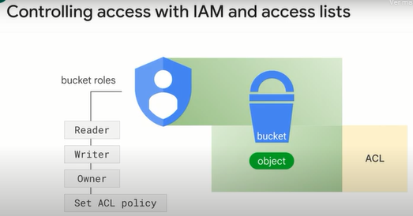

All data in Google Cloud is encrypted at rest and in transit.

There is no way to turn this encryption off.

The encryption is done by Google using encryption keys that we manage, Google-managed encryption keys, or GMEK.

We use two levels of encryption.

First, the data is encrypted using a data encryption key.

Then the data encryption key itself is encrypted using a key encryption key, or KEK.

The KEKs are automatically rotated on a schedule, and the current KEK stored in Cloud KMS, Cloud Key Management Service.

You don't have to do anything.

This is automatic behavior.

If you want to manage the KEK yourself, you can.

Instead of Google managing the encryption key, you can control the creation and existence of the KEK that is used.

This is called customer-managed encryption keys, or CMEK.

You can avoid Cloud KMS completely and supply your own encryption and rotation mechanism.

This is called CSEK, or customer-supplied encryption keys.

Which data encryption option you use depends on business, legal and regulatory requirements.

Please talk to your company's legal counsel.

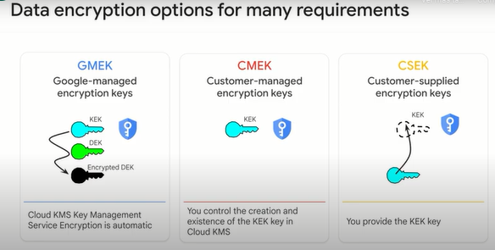

The fourth encryption option is client-side encryption.

Client-side encryption simply means that you have encrypted the data before it is uploaded and have to decrypt the data yourself before it is used.

Cloud Storage still performs GMEK, CMEK or CSEK encryption on the object.

It has no knowledge of the extra layer of encryption you may have added.

Cloud Storage supports logging of data access, and these logs are immutable.

In addition to Cloud audit logs and Cloud Storage access logs, there are various holds and locks that you can place on the data itself.

For audit purposes, you can place a hold on an object, and all operations that could change or delete the object are suspended until the hold is released.

You can also lock a bucket, and no changes or deletions can occur until the lock is released.

Finally, there is the lock retention policy previously discussed, and it continues to remain in effect and prevent deletion, whether a bucket lock or object hold are in-force or not.

Data locking is different from encryption.

Where encryption prevents someone from understanding the data, locking prevents them from modifying the data.

There are a whole host of special use cases supported by Cloud Storage.

For example, decompressive coding.

By default, the data you upload is the same data you get back from Cloud Storage.

This includes gzip archives, which usually are returned as gzip archives.

However, if you tag an object properly in metadata, you can cause Cloud Storage to decompress the file as it is being served.

Benefits of the smaller compressed file are faster upload and lower storage costs compared with the uncompressed files.

You can set up a bucket to be requester pays on access.

Normally, if data is accessed from a different region, you will have to pay network egress charges, but you can make the requester pay so that you pay only for data storage.

You can create a signed URL to anonymously share an object in Cloud Storage, and even have the URL expire after a period of time.

It is possible to upload an object in pieces and create a composite object without having to concatenate the pieces after upload.

There are a lot of useful features in Cloud Storage, but we have to move on.

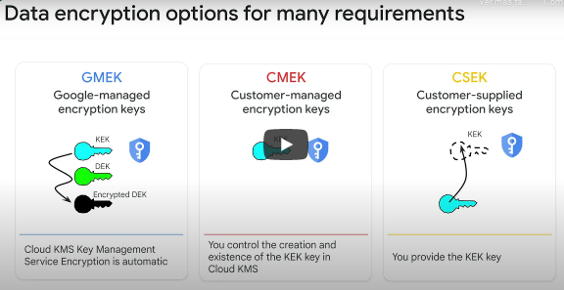

**Store all sorts of data types.**

As highlighted before, Cloud Storage isn't your only choice when it comes to storing data on Google Cloud.

You don't want to use Cloud Storage for transactional workloads.

Even though the latency of Cloud Storage is low, it is not low enough to support high-frequency writes.

For transactional workloads, use Cloud SQL or Firestore depending on whether you want to SQL or NoSQL.

You also don't want to use Cloud Storage for analytics on structured data.

If you do that, you will spend a significant amount of compute parsing data.

It is better to use Cloud Bigtable or BigQuery for analytics workloads on structured data depending on the latency required.

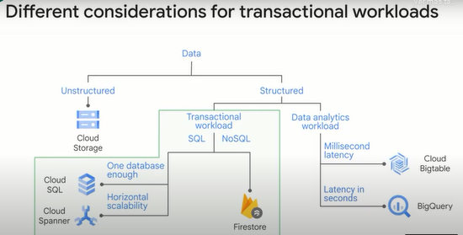

We keep talking about transactional versus analytics workloads.

What exactly do we mean?

Transactional workloads are ones where you require fast inserts and updates.

You want to maintain a snapshot, a current state of the system.

The trade-off is that queries tend to be relatively simple and tend to affect only a few records.

For example, in a banking system, depositing your salary to your account is a transaction.

It updates the balance field.

The bank is doing online transaction processing, or OLTP.

An analytics workload on the other hand tends to read the entire data set and is often used for planning or decision support.

The data might come from a transaction processing system but is often consolidated from many OLTP systems.

For example, a bank regulator might require us to provide a report of every customer who transferred more than $10,000 to an overseas account.

They might ask the bank to include customers who try to transfer the $10,000 in smaller chunks over the period of a week.

A report like this will require scanning through a significantly large data set and require a complex query that involves aggregating over moving time windows.

This is an example of online analytical processing, or an OLAP, workload.

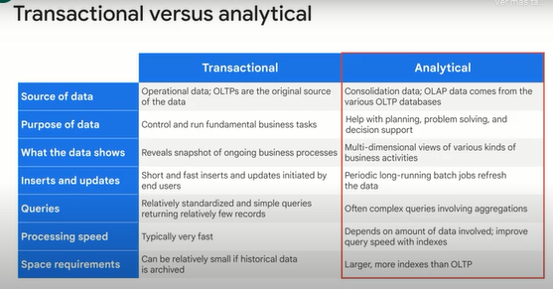

The reason we treat these use cases differently is that transactional systems are right-heavy.

These tend to be operational systems.

For example, a retailer's catalog data will require updating every time the retailer adds a new item or changes the price.

The inventory data will need to be updated every time the retailer sells an item.

This is because the catalog and inventory systems have to maintain an up-to-the-moment snapshot of the business.

Analytical systems can be periodically populated from the operational systems.

We could use this once a day to generate a report of items in our catalog whose sales are increasing but whose inventory levels are low.

Such a report will have to read a bunch of data but not have to write much.

OLAP systems are read-focused.

Recall what we said.

Analytical systems can be periodically populated from the operational systems.

Data engineers build the pipelines to populate the OLAP system from the OLTP system.

One simple way might be to export the database as a file and load it into the data warehouse.

This is what we call EL.

On Google Cloud, the data warehouse tends to be BigQuery.

There is a limit to the size of the data that you can directly load to BigQuery.

This is because your network might be a bottleneck.

Rather than load the data directly into BigQuery, it can be much more convenient to first load it to Cloud Storage and load from Cloud Storage to BigQuery.

This is because Cloud Storage supports multithreaded, resumable loads.

Just provide the -m option to gsutil.

Loading from Cloud Storage will also be faster because of the high throughput it offers.

Getting back to the discussion on transactional workloads, you have a few options for relational databases.

The default choice here is Cloud SQL, but if you require a globally distributed database, then use Cloud Spanner.

You'd want a globally distributed database if your database will see updates from applications running in different geographic regions.

The true time capability of Spanner is very appealing for this kind of use case.

Another reason you might choose Spanner is if your database is too big to fit into a single Cloud SQL instance.

If our database is many gigabytes, you need a distributed database.

The scalability of Spanner is very appealing for this use case.

Other than that, you'd use Cloud SQL because it is more cost-effective.

For analytics workloads, the default choice is BigQuery.

However, if you require high-throughput inserts, more than millions of rows per second, or if you require a low latency on the order of milliseconds, use Cloud Bigtable.

Other than that, you'd use BigQuery because it is more cost-effective.

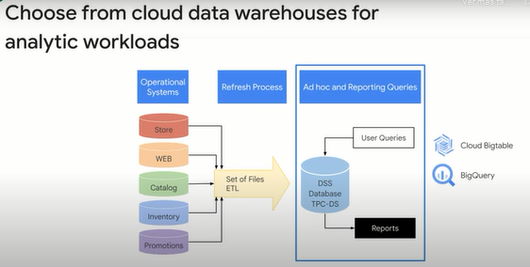

**Cloud SQL as a relational data lake.**

Cloud SQL, we said, is the default choice for OLTP, or Online Transaction Processing, workloads on Google Cloud.

Let's take a quick look.

Cloud SQL is an easy-to-use service that delivers fully managed relational databases.

Cloud SQL lets you hand off to Google the mundane but necessary and often time-consuming tasks like applying patches and updates, managing backups and configuring replications so you can put your focus on building great applications.

Cloud SQL is our managed service for third-party RDBMSes.

It supports MySQL, PostgreSQL and Microsoft SQL Server, and additional RDBMSes will be added over time.

What this means is that we provide a Compute Engine instance that has MySQL already installed.

We'll manage the instance on your behalf.

We'll do backups.

We'll do security updates and update the minor versions of the software so that you don't have to worry about that.

In other words, Google Cloud manages the MySQL database to the point where you can treat it as a service.

We even do DBA-like things.

You can tell us to add a failover replica for your database.

We'll manage it for you, and you'll have a 99.95-percent availability SLA.

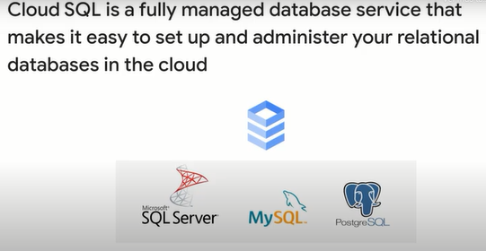

Another benefit of Cloud SQL instances is that they are accessible by other Google Cloud services and even external services.

You can use Cloud SQL with App Engine using standard drivers like Connector/J for Java or MySQL DB for Python.

You can authorize Compute Engine instances to access Cloud SQL instances and configure the Cloud SQL instance to be in the same zone as your virtual machine.

Cloud SQL also supports other applications and tools that you might be used to like SQL Workbench, Toad and other external applications using standard MySQL drivers.

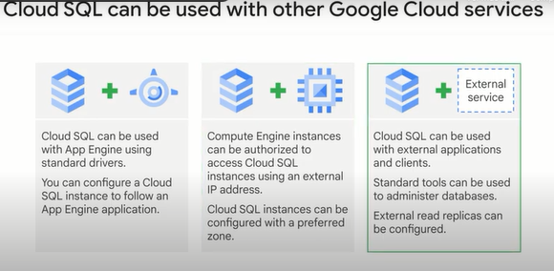

One of the advantages of Google managing your database is that you get the benefits of Google security.

Cloud SQL customer data is encrypted when on Google's internal networks and when stored in database tables, temporary files and backups.

Every Cloud SQL instance includes a network firewall, allowing you to control network access to your database instance by granting access.

Cloud SQL is easy to use.

It doesn't require any software installation or maintenance, and Google manages the backups.

Cloud SQL takes care of securely storing your backed-up data makes it easy for you to restore from a backup and perform a point-in-time recovery to a specific state of an instance.

Cloud SQL retains up to seven backups for each instance, which is included in the cost of your instance.

You can vertically scale Cloud SQL.

Just increase your machine size.

Scale up to 64 processor cores and more than 100 gigabytes of RAM.

Horizontally, you can quickly scale out with read replicas.

Google Cloud SQL supports three read replica scenarios: Cloud SQL instances replicating from a Cloud SQL primary instances, Cloud SQL instances replicating from an external primary instance, external MySQL instances replicating from a Cloud SQL primary instance.

If you need horizontal read-write scaling, consider Cloud Spanner.

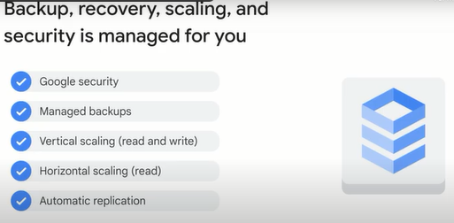

For the special case of failover, Cloud SQL supports this.

Cloud SQL instances can be configured with a failover replica in a different zone in the same region.

Then Cloud SQL data is replicated across zones within a region for durability.

In the unlikely event of a data center outage, a Cloud SQL instance will automatically become available in another zone.

All changes made to data on the primary are replicated to failover.

If the primary instances zone has an outage, Cloud SQL automatically fails over to the replica.

If the primary has issues not caused by a zone outage, failover doesn't occur.

You can, however, initiate failover manually.

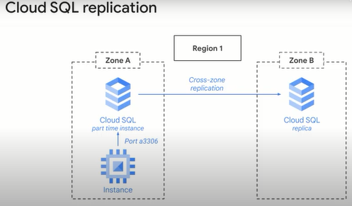

There are a few caveats (*advertencias*).

Note that the failover replica is charged as a separate instance.

When a zonal outage occurs and your primary fails over to your failover replica, any existing connections to the instance are closed.

However, your application can reconnect using the same connection string or IP address.

You do not need to update your application after a failover.

After the failover, the replica becomes the primary, and Cloud SQL automatically creates a new failover replica in another zone.

If you located your Cloud SQL instance to be near other resources such as a Compute Engine instance, you can relocate your Cloud SQL instance back to its original zone when the zone becomes available.

Otherwise, there is no need to relocate your instance after a failover.

You can use the failover replica as a read replica to offload read operations from the primary.

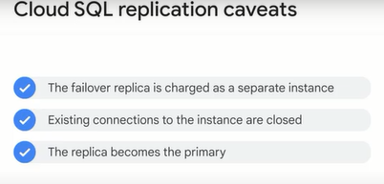

We keep saying that Cloud SQL is fully managed.

We have also used the word serverless to describe BigQuery, for example.

What's the difference?

By fully managed, we mean that the service runs on hardware that you can control.

You can SSH into a Cloud SQL instance, for example.

That said, Google helps you manage the instance, for example, by automating backups and setting up failover instances, et cetera.

Serverless is the next step up.

You can treat a serverless product as just an API that you are calling.

You pay for using the product but don't have to manage any servers.

**BigQuery is serverless.**

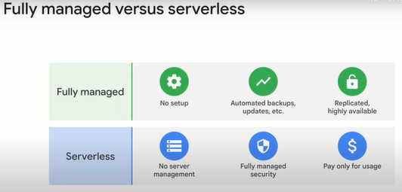

So are Pub/Sub for asynchronous messaging and Dataflow for parallel data processing.

You can think of Cloud Storage as being serverless, as well.

Sure, Cloud Storage uses disks, but you never actually interact with the hardware.

One of the unique things about Google Cloud is that you can build a data processing pipeline of well designed components, all of which are fully serverless.

Dataproc, on the other hand, is fully managed.

It helps you run Spark and Hadoop workloads without having to worry about setup.

Given the choice between doing a brand-new project on BigQuery or Dataflow, which are serverless, and Dataproc, which is fully managed, which one should you choose?

All other things being equal, choose the serverless product.

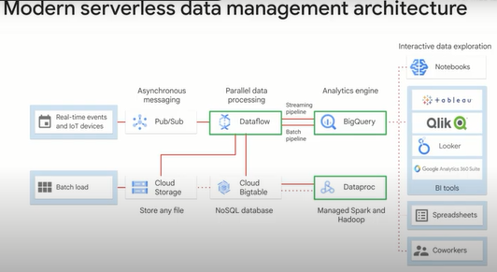

**Lab: Loading Taxi Data into Google Cloud SQL 2.5.**

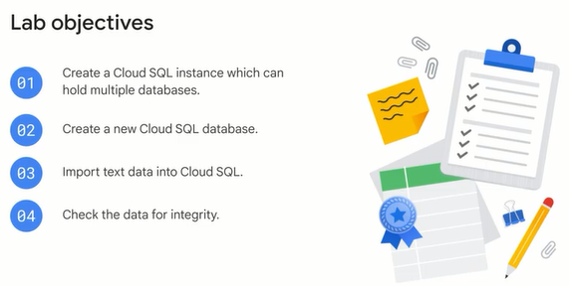

**Overview**

In this lab, you will learn how to import data from CSV text files into Cloud SQL and then carry out some basic data analysis using simple queries.

The dataset used in this lab is collected by the NYC Taxi and Limousine Commission and includes trip records from all trips completed in Yellow and Green taxis in NYC from 2009 to present, and all trips in for-hire vehicles (FHV) from 2015 to present. Records include fields capturing pick-up and drop-off dates/times, pick-up and drop-off locations, trip distances, itemized fares, rate types, payment types, and driver-reported passenger counts.

This dataset can be used to demonstrate a wide range of data science concepts and techniques and will be used in several of the labs in the Data Engineering curriculum.

## **Preparing your Environment**

Create environment variables that will be used later in the lab for your project ID and the storage bucket that will contain your data:

export PROJECT_ID=$(gcloud info --format='value(config.project)')

export BUCKET=${PROJECT_ID}-ml

## Create a Cloud SQL instance

Enter the following commands to create a Cloud SQL instance:

gcloud sql instances create taxi \

--tier=db-n1-standard-1 --activation-policy=ALWAYS

This will take a few minutes to complete.

### **Test Completed Task**

Click **Check my progress** to verify your performed task. If you have completed the task successfully you will granted with an assessment score.

Set a root password for the Cloud SQL instance:

gcloud sql users set-password root --host % --instance taxi \

--password Passw0rd

When prompted for the password type Passw0rd and press enter this will update root password.

Now create an environment variable with the IP address of the Cloud Shell:

export ADDRESS=$(wget -qO - http://ipecho.net/plain)/32

Whitelist the Cloud Shell instance for management access to your SQL instance.

gcloud sql instances patch taxi --authorized-networks $ADDRESS

When prompted press **Y** to accept the change.

### **Test Completed Task**

Click **Check my progress** to verify your performed task. If you have completed the task successfully you will granted with an assessment score.

Whitelist the Cloud Shell instance to access your SQL instance.

Check my progress

Get the IP address of your Cloud SQL instance by running:

MYSQLIP=$(gcloud sql instances describe \

taxi --format="value(ipAddresses.ipAddress)")

Check the variable MYSQLIP:

echo $MYSQLIP

you should get an IP address as an output.

Create the taxi trips table by logging into the mysql command line interface.

mysql --host=$MYSQLIP --user=root \

--password --verbose

When prompted for a password enter Passw0rd. Paste the following content into the command line to create the schema for the trips table:

create database if not exists bts;

use bts;

drop table if exists trips;

create table trips (

vendor_id VARCHAR(16),

pickup_datetime DATETIME,

dropoff_datetime DATETIME,

passenger_count INT,

trip_distance FLOAT,

rate_code VARCHAR(16),

store_and_fwd_flag VARCHAR(16),

payment_type VARCHAR(16),

fare_amount FLOAT,

extra FLOAT,

mta_tax FLOAT,

tip_amount FLOAT,

tolls_amount FLOAT,

imp_surcharge FLOAT,

total_amount FLOAT,

pickup_location_id VARCHAR(16),

dropoff_location_id VARCHAR(16)

);

### **Test Completed Task**

Click **Check my progress** to verify your performed task. If you have completed the task successfully you will granted with an assessment score.

Create a bts database and trips table.

Check my progress

In the mysql command line interface check the import by entering the following commands:

describe trips;

Query the trips table:

select distinct(pickup_location_id) from trips;

This will return an empty set as there is no data in the database yet.

Exit the mysql interactive console:

exit

## Add data to Cloud SQL instance

Now you'll copy the New York City taxi trips CSV files stored on Cloud Storage locally. To keep resource usage low, you'll only be working with a subset of the data (~20,000 rows).

Run the following in the command line:

gsutil cp gs://cloud-training/OCBL013/nyc_tlc_yellow_trips_2018_subset_1.csv trips.csv-1

gsutil cp gs://cloud-training/OCBL013/nyc_tlc_yellow_trips_2018_subset_2.csv trips.csv-2

Copied!

content_copy

Connect to the mysql interactive console to load local infile data:

mysql --host=$MYSQLIP --user=root --password --local-infile

When prompted for a password enter Passw0rd.

In the mysql interactive console select the database:

use bts;

Load the local CSV file data using local-infile:

LOAD DATA LOCAL INFILE 'trips.csv-1' INTO TABLE trips

FIELDS TERMINATED BY ','

LINES TERMINATED BY '\n'

IGNORE 1 LINES

(vendor_id,pickup_datetime,dropoff_datetime,passenger_count,trip_distance,rate_code,store_and_fwd_flag,payment_type,fare_amount,extra,mta_tax,tip_amount,tolls_amount,imp_surcharge,total_amount,pickup_location_id,dropoff_location_id);

LOAD DATA LOCAL INFILE 'trips.csv-2' INTO TABLE trips

FIELDS TERMINATED BY ','

LINES TERMINATED BY '\n'

IGNORE 1 LINES

(vendor_id,pickup_datetime,dropoff_datetime,passenger_count,trip_distance,rate_code,store_and_fwd_flag,payment_type,fare_amount,extra,mta_tax,tip_amount,tolls_amount,imp_surcharge,total_amount,pickup_location_id,dropoff_location_id);

## **Checking for data integrity**

Whenever data is imported from a source it's always important to check for data integrity. Roughly, this means making sure the data meets your expectations.

Query the trips table for unique pickup location regions:

select distinct(pickup_location_id) from trips;

Copied!

content_copy

This should return 159 unique ids. Let's start by digging into the trip_distance column. Enter the following query into the console:

select

max(trip_distance),

min(trip_distance)

from

trips;

Copied!

content_copy

One would expect the trip distance to be greater than 0 and less than, say 1000 miles. The maximum trip distance returned of 85 miles seems reasonable but the minimum trip distance of 0 seems buggy. How many trips in the dataset have a trip distance of 0?

select count(*) from trips where trip_distance = 0;

Copied!

content_copy

There are 155 such trips in the database. These trips warrant further exploration. You'll find that these trips have non-zero payment amounts associated with them. Perhaps these are fraudulent transactions? Let's see if we can find more data that doesn't meet our expectations. We expect the fare_amount column to be positive. Enter the following query to see if this is true in the database:

select count(*) from trips where fare_amount < 0;

Copied!

content_copy

There should be 14 such trips returned. Again, these trips warrant further exploration. There may be a reasonable explanation for why the fares take on negative numbers. However, it's up to the data engineer to ensure there are no bugs in the data pipeline that would cause such a result.

Finally, let's investigate the payment_type column.

select

payment_type,

count(*)

from

trips

group by

payment_type;

Copied!

content_copy

The results of the query indicate that there are four different payment types, with:

* payment type = 1 has 13863 rows
* payment type = 2 has 6016 rows
* payment type = 3 has 113 rows
* payment type = 4 has 32 rows

Digging into [the documentation](https://www1.nyc.gov/assets/tlc/downloads/pdf/data_dictionary_trip_records_yellow.pdf), a payment type of 1 refers to credit card use, payment type of 2 is cash, and a payment type of 4 refers to a dispute. The figures make sense.

Exit the 'mysql' interactive console:

exit

Copied!

content_copy

## **End your lab**

**Quizz.**

1. Which statement best describes a data lake?

Storage for current/historical data intended for reporting.

Storage optimized for high-throughput writes.

Data storage intended for analytics.

**The place where you capture every aspect of your business operations. Data is stored in its natural, raw format.**

2. Which of the following statements on Cloud Storage are true?

Data in Cloud Storage is not encrypted

**Cloud Storage implements both IAM policy and Access Control Lists**

**Cloud Storage allows you to set retention policies on all objects in a bucket**

**Cloud Storage simulates a file system**